1 – 5 – Recognizing Transformations – Practice Set
1. [P] Transformation Practice. For each of the functions, write its transformed equation after you:
(i) shift left by 3 units, (ii) shift down by 2 units, (iii) shift right by 1 unit and up by 4 units.
a. $f\left(x\right)={(x-2)}^{2}$
b. $f\left(x\right)=4-sin\left(x\right)$

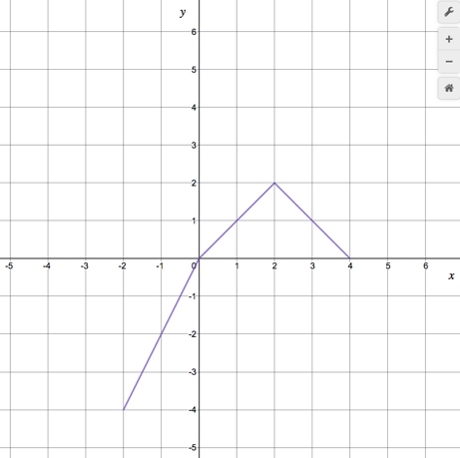
2. [P] Transforming a graph. Given the graph for f(x), plot:
a) $f\left(x-2\right),$
$$b) f\left(2x\right),$$
$$c) 2f\left(x\right),$$
$$d) f\left(x\right)+2,$$
$$e)-f(-x)$$

3. [P] For each equation below tell me what basic family it is, and how it’s been transformed (in words). Then make a quick sketch of its overall shape and key features / reference points without using a table of values.
a). $f\left(x\right)=3-\frac{1}{x}$
b). $g\left(x\right)=-5^{x-1}$
c). $g\left(x\right)=2⋅5^{-x}$

4. [P/C] Focus on horizontal reflection.
a). If I have a function f(x) and I want to translate it down vertically by k I can write: $f\left(x\right)-k$. What would you write if you wanted to reflect it horizontally?
b). Ok, now say that $f\left(x\right)=x^{3}-x$ , what would the equation look like when you reflect it horizontally?
c). What about $f\left(x\right)=x^{2}+5$ ? Is the horizontally reflected equation actually different? Will the graph look different? Explain.
d). What about $g\left(x\right)=\frac{x}{3 - x^{2}}$ ? What will its equation look like after horizontal reflection? Is the new equation actually different? Will the graph look different?

1 – 5 – Recognizing Transformations – Solutions
1. [P] Transformation Practice. For each of the functions, write its transformed equation after you:
(i) shift left by 3 units, (ii) shift down by 2 units, (iii) shift right by 1 unit and up by 4 units.
a. $f\left(x\right)={(x-2)}^{2}$
i. Shift left by 3: $f(x+3)$, so substituting $x+3$ for x gives: $f\left(x\right)={\left(x+1\right)}^{2}$
ii. Shift down by 2: $f\left(x\right)-2$, so $f\left(x\right)={\left(x-2\right)}^{2}-2$
iii. Shift right by 1 and up by 4: $f\left(x-1\right)+4$, giving: $f\left(x\right)={\left(x-3\right)}^{2}+4$

b. $f\left(x\right)=4-sin\left(x\right)$
(i) shift left by 3 units: $f\left(x\right)=4-\sin\left(x+3\right)$
(ii) shift down by 2 units: $f\left(x\right)=2-sin⁡(x)$
(iii) shift right by 1 unit and up by 4 units: $f\left(x\right)=8-\sin\left(x+3\right)$

2. [P] Transforming a graph. Given the graph for f(x), plot:
) $f\left(x-2\right),$ | $$f\left(2x\right),$$ | $$2f\left(x\right)$$
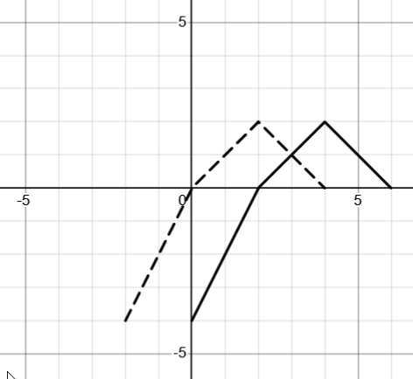 | 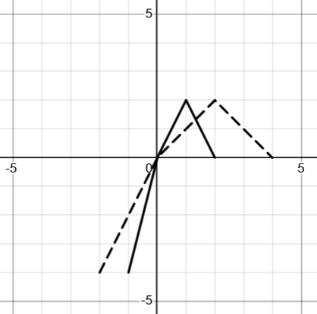 | 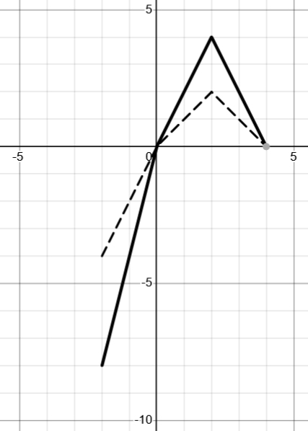
$$f\left(x\right)+2,$$ | $$-f(-x)$$
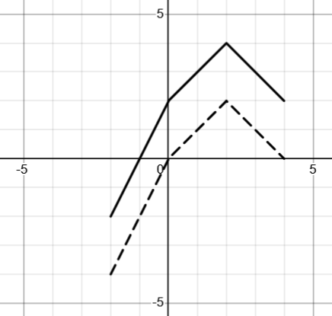 | 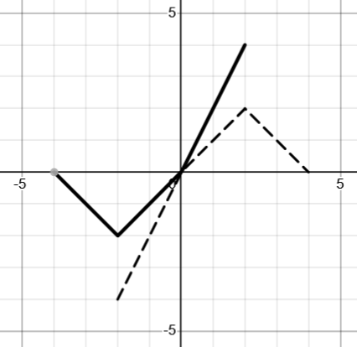
3. [P] For each equation below tell me what basic family it is, and how it’s been transformed (in words). Then make a quick sketch of its overall shape and key features / reference points without using a table of values.
a). $f\left(x\right)=3-\frac{1}{x}$

This is the $y=\frac{1}{x}$ family (sometimes called the reciprocal function).
You could write it this way: $f\left(x\right)=-\frac{1}{x}+3$ to see that it’s been shifted up by 3.

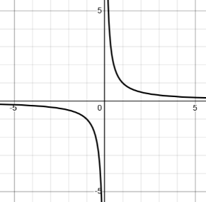
You can think about $f\left(x\right)=-\frac{1}{x}$ as either: $-\left(\frac{1}{x}\right)$ or as $\frac{1}{-x}$ .

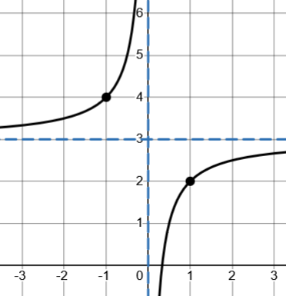
They’re the same, which makes sense because if you think about the basic family (shown to the left), vertically reflecting will give you the same result as horizontally reflecting.

So, the final shape shown to the right has a horizontal asymptote at $y=3$, a vertical asymptote at $x=0$, and the two reference points shown at $(1,2)$ and $(-1, 4)$

b). $g\left(x\right)=-5^{x-1}$
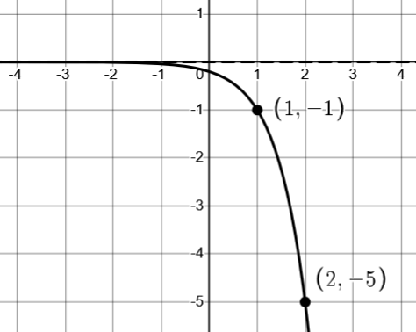
This is the $y=5^{x}$ (exponential) family. $y=5^{x-1}$ shifts it right by 1. $y=-5^{stuff}$ vertically reflects it. The final shape looks like this.

The point at $(0,1)$ on $y=5^{x}$ reflected and shifted to $(1,-1)$.

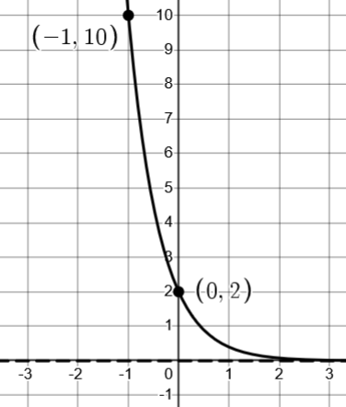
c). $g\left(x\right)=2⋅5^{-x}$
This is also the $y=5^{x}$ family.
$y=5^{-x}$ horizontally reflects, and $y=2⋅\left(5^{-x}\right)$ vertically scales it by 2.
Note the two reference points: $(0, 1)$ on $y=5^{x}$ vertically scaled to $(0,2)$
$(1, 5)$ on $y=5^{x}$ horizontally reflected and scaled to $(-1, 10)$

4. [P/C] Focus on horizontal reflection.
a). If I have a function f(x) and I want to translate it down vertically by k I can write: $f\left(x\right)-k$. What would you write if you wanted to reflect it horizontally?
$$f(-x)$$
b). Ok, now say that $f\left(x\right)=x^{3}-x$ , what would the equation look like when you reflect it horizontally?
The last answer says that a horizontal reflection is: $f(-x)$.
So imagine using $-x$ as the input to $f\left(x\right)=x^{3}-x$. That gives: $f\left(-x\right)={\left(-x\right)}^{3}-\left(-x\right)=-x^{3}+x$

c). What about $f\left(x\right)=x^{2}+5$ ? Is the horizontally reflected equation actually different? Will the graph look different? Explain.
Here if we find $f(-x)$ it gives $f\left(-x\right)={\left(-x\right)}^{2}+5=x^{2}+5$
So the equation didn’t actually change. That makes sense because the graph didn’t actually change either. If you imagine an up-shifted parabola $y=x^{2}+5$, horizontally reflecting it gives you the exact same thing.

d). What about $g\left(x\right)=\frac{x}{3 - x^{2}}$ ? What will its equation look like after horizontal reflection? Is the new equation actually different? Will the graph look different?
If we find $g\left(-x\right)$ we get $g\left(-x\right)=\frac{-x}{3-{\left(-x\right)}^{2}}=-\frac{x}{3 - x^{2}}$
So the equation changes, as does the graph. Something that stands out to me is that the graph actually reflected vertically. So even if you’re not sure what it looks like, you can conclude it must be a shape where vertical and horizontal reflection give the same outcome (as we saw with $y=\frac{1}{x}$ ).

1 – 6 – Recognizing Transformations – Practice Set
1. These should take no more than 1 minute each.

a). Scale $y=x^{3}$ so it passes through the point (1, 15). Write its equation.

b). Scale $y=x^{3}$ so it passes through the point (17, 1). Write its equation.

c). Scale $y=x^{3}$so it passes through the point (21, 23). Write its equation.

d). If $f\left(x\right)=\sin\left(x\right).$ I want to have one of the peaks of the curve passing thru $\left(\frac{3}{2}π,3\right)$. Scale and/or shift it so this happens.

2. [P] Perform each transformation to get an equation.
a. If I have a linear function with slope of 1/2, write the equation for it to pass through the point (4,3)
b. If I have $y=x^{2}$ horizontally scale it so it passes through (11, 1)
c. If I have $y=x^{2}$ vertically scale it so it passes through $(1, \sqrt{11}$)
d. If I have $y=2^{x}$ horizontally scale it so it passes through (11, 1)
e. If I have $y=2^{x}$ vertically scale it so it passes through $(1, \sqrt{11}$)
f. If I have $y=\sqrt[3]{x}$ horizontally scale it so it passes through (11, 1)
g. If I have $y=\sqrt[3]{x}$ vertically scale it so it passes through $(1, \sqrt{11}$)
h. If I have $y=x^{4}$ vertically scale it so that it passes through $(2, π$). (you’ll need to think about the current y-value of $x^{4}$ at x = 2 to decide how it needs to get scaled).

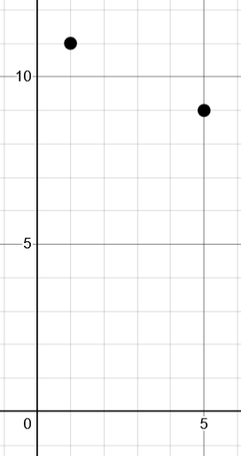
3. [P] Here’s a picture of the points $(1, 11)$ and $(5, 9)$.

a. Find the equation of a parabola that goes through both points.
b. Find the equation for a cubic function that goes through both points.
c. Find the equation of a square root function that goes through both points.

4. [P/C]
Say we need to write the equations for 6 different lines that all go through the point (13, 24) in less than 1 minute.
a. Why is $y=mx+b$ form not going to work for this? What form is a better choice?
b. Ok, now do it. Spend less than 1 minute and write the equations of 6 different lines that all go through the point $(13, 24)$.

1 – 6 – Recognizing Transformations – Solutions
1. These should take no more than 1 minute each.

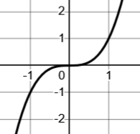
a). Scale $y=x^{3}$ so it passes through the point (1, 15). Write its equation.

If you picture in your mind, you can do this without setting up equations at all. $y=x^{3}$ has a reference point at $(1, 1)$, so scaling it vertically by 15 will put it at $(1, 15)$.
So: $y=15⋅x^{3}$

This only worked because the numbers were so easy. You could, of course, set up an equation with a scale factor: $y=k⋅x^{3}$ and then plug in the x and y that should satisfy the equation to solve for the k value that makes them do that. So: $15=k⋅1^{3}$ giving $k=15$. This is what we got above just by thinking about it.

b). Scale $y=x^{3}$ so it passes through the point (17, 1). Write its equation.

Here you can imagine how to scale it horizontally to stretch $(1,1)$ to $(17, 1)$.
That immediately gives $y={\left(\frac{1}{17}x\right)}^{3}$

Another way to think about it is to “squish” it vertically. But by how much? At $x=17$ the original function has a y-value of $y={17}^{3}$. So if we want that to squish down to 1, just divide by that same number. That gives you $y=\frac{1}{{17}^{3}}⋅x^{3}$ (Notice that this is equivalent to the last equation).

c). Scale $y=x^{3}$so it passes through the point (21, 23). Write its equation.

An easy way to think about this is to take the value at x = 21, squish it down to 1 so that way we can scale it back up to 23. At $x=21$ the y-value is $y={21}^{3}$. If we write $y=\frac{1}{{21}^{3}}⋅x^{3}$ that squishes the y-value down to 1. So now let’s add one more vertical scale to stretch it back up to 23. That gives $y=\frac{23}{{21}^{3}}⋅x^{3}$

d). If $f\left(x\right)=\sin\left(x\right).$ I want to have one of the peaks of the curve passing thru $\left(\frac{3}{2}π,3\right)$. Scale and/or shift it so this happens.
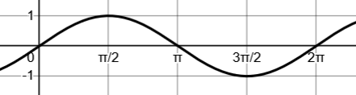
Let’s start by imagining what the shape looks like. It’s got a point at $\left(\frac{3}{2}π, -1\right)$. So I can see that if I reflect it veritcally, the y-value will go to +1, then I can scale it by 3 to put it at $y=3$.

That gives $y=-3\sin\left(x\right)$

2. [P] Perform each transformation to get an equation.
a. If I have a linear function with slope of 1/2, write the equation for it to pass through the point (4,3)

Remember from the last set. Vertically scale $y=x$ to have the right slope: $y=\frac{1}{2}$.
Now shift right 4 and up 3 to get $y=\frac{1}{2}\left(x-4\right)+3$

b. If I have $y=x^{2}$ horizontally scale it so it passes through (11, 1)

We can horizontally stretch it by 11 to send the point at $(1, 1)$ to $(11, 1)$: $y={\left(\frac{1}{11}x\right)}^{2}$

c. If I have $y=x^{2}$ vertically scale it so it passes through $(1, \sqrt{11}$)

We can vertically stretch by $\sqrt{11}$: $y=\sqrt{11}{⋅x}^{2}$. The key here is to see $\sqrt{11}$ and think: “that’s just a number, like 3, or 11”.

d. If I have $y=2^{x}$ horizontally scale it so it passes through (11, 1)

e. If I have $y=2^{x}$ vertically scale it so it passes through $(1, \sqrt{11}$)

f. If I have $y=\sqrt[3]{x}$ horizontally scale it so it passes through (11, 1)

g. If I have $y=\sqrt[3]{x}$ vertically scale it so it passes through $(1, \sqrt{11}$)

h. If I have $y=x^{4}$ vertically scale it so that it passes through $(2, π$). (you’ll need to think about the current y-value of $x^{4}$ at x = 2 to decide how it needs to get scaled).


3. [P] Here’s a picture of the points $(1, 11)$ and $(5, 9)$.

a. Find the equation of a parabola that goes through both points.
b. Find the equation for a cubic function that goes through both points.
c. Find the equation of a square root function that goes through both points.

4. [P/C]
Say we need to write the equations for 6 different lines that all go through the point (13, 24) in less than 1 minute.
a. Why is $y=mx+b$ form not going to work for this? What form is a better choice?
b. Ok, now do it. Spend less than 1 minute and write the equations of 6 different lines that all go through the point $(13, 24)$.

